**Peer-graded Assignment: Capstone Project - The Battle of Neighborhoods (Week 1)**

**WEEK1**

1. **A description of the problem and a discussion of the background**

We are a digital start up in the process of launching a new revolutionary app.

Our product = **“Pub Quiz Champions”**

An App that will help you to organize any Pub Quiz like a professional.

Thanks to the apps you can play with your friend in face to face at home or in a pub or you can play virtually from any distance which is quite convenient during this difficult time of COVID lockdown.

But first think first : What is a Pub Quiz ?

**Pub quiz**

*From Wikipedia,*

*A pub quiz is a quiz held in a pub or bar. These events are also called quiz nights[1], trivia nights[2], or bar trivia[3] and may be held in other settings. Pub quizzes may attract customers to a pub who are not found there on other days. The pub quiz is a modern example of a pub game. Although different pub quizzes can cover a range of formats and topics, they have many features in common. The pub quiz was established in the UK in the 1970s by Burns and Porter and became part of British culture.[4] The Great British Pub Quiz challenge is an annual event.[4] In continental Europe, pub quizzes are a staple event at Irish pubs, where they are usually held in English.*

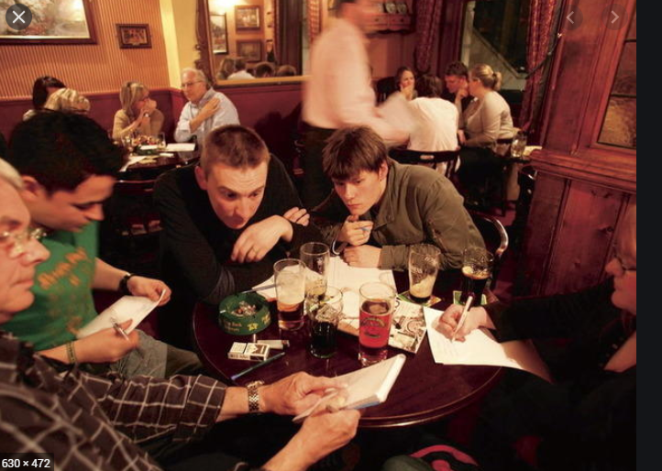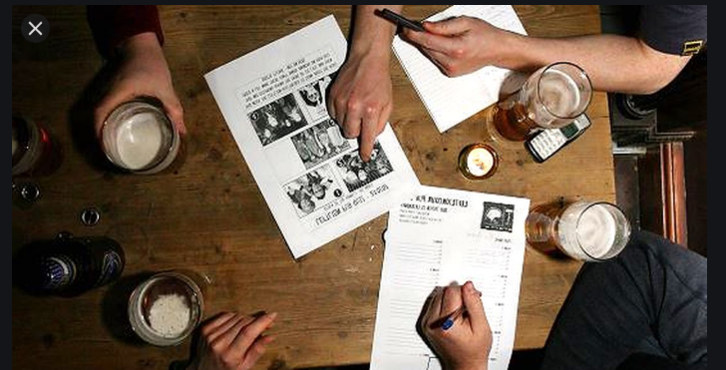

We are now in the last phases of the projects and are preparing our communication plan for the launch of the product.

The customer audience we want to target is :

* Fan of quiz , pub aficionados , pub owners
* Our test market is London UK

Our communication plan will be composed of :

* Organization of live events in different Pub where we will demonstrate the added values of our products
* Digital advertising campaigns ( social media + display ads ) that will be geo targeted on the areas where we find the most frequented pub.

**The problem :**

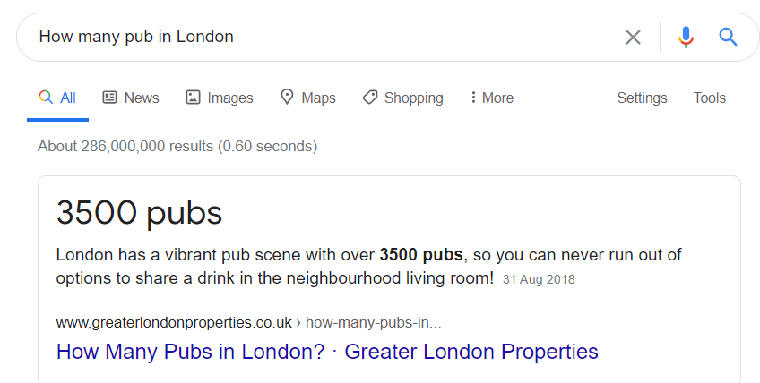

We don’t have a huge communication budget so it’s not possible for us to target the 3500 London pubs.

To make our communication plan a success:

We need to identify and create a selection of London areas where we will start our communication plan.

We want to identify which areas of London are distinguished by the frequency of pub visits.